**SYSTEM REQUIREMENT SPECIFICATION**

**1 INTRODUCTION**

**1.1 PURPOSE**

The purpose of this document is to outline the operational requirements to our website in order to make it more attractive, efficient and user-friendly.

The purpose of Designing Online Computerised Paperless Examination is to gives the Job Seekers a Platform for finding a Right and a Satisfactory Job According to their qualification and need. It also Connect The Job Seekers With Major Companies. This Online Computerised paperless examination is created for providing all categories of job and help to get various types of jobs in various fields. The main purpose of this online computerised paperless examination system is to provides the facility to job seekers for getting the quick jobs during there academic duration or after this.

**1.2 SCOPE OF PROJECT**

This web portal is developed for creating an interactive job vacancy From Particular Company for candidates. This web application is to be conceived in its current form as a dynamic site-requiring constant updates both from the seekers as well as the companies. The hiring of Candidates For Job Which is Posted By Particular Company Is based On Assessments which is from Company on the Basis of Company Requirement.

We are using Python/PHP technology with MySQL RDBMS for API Paperless-examination for recruitment and answers to stored in data base tables in encrypted format.

**1.3 INTENDED AUDIENCE**

**TESTERS** The testers would use this document to know the interface website.

**1.4 DEFINITIONS, ACRONYMS, AND ABBREVIATIONS**

**SRS** –Software Requirement Specification, this document which outlines the requirementsthat the software must fulfil entirely design independent.

**User** –Any person who uses the website and access its content.

**Member** –Any person who uses the website and access its content but after takingmembership.

**Administrator** –A person who has administrative access to the advanced settings.

**RDBMS**: Relational Database Management Systems.

**2 OVERALL DESCRIPTION**

**2.1 PRODUCT PERSPECTIVE**

This product is designed in order to provide easy way for the companies to recruit candidate according to their criteria and have analytical reports of each candidate from online examination on portal so that all the data of applicants can accessed from one server.

**2.2 PRODUCT FUNCTIONALITY**

This product provides various feature to the companies like help them monitor any scheme see how many candidate are enrolled. The system also give the analytical report of company recruitments according to the whole placement drive process.

**2.3 USER CHARACTERISTICS**

There is no any specific characteristics required but user should know how to operate internet and should contain all the valid documents to register to portal.

**2.4 OPERATING ENVIRONMENT**

The operating environment of this project used some software and operating system. The Online Paper-less examination for recruitment of students is being developed in python/php technology so the software, hardware and operating system used are:-

**OPERATING SYSTEM**

Windows 7/8/10

**SOFTWARE REQUIREMENT**

Web-browser:Chrome, Mozilla FireFox, Explorer any browser used that allow to run web application or web pages including latest compatibility of web designing framework.

Xampp Server:It is a web server which allow to run PHP file and MySQL database.

**HARDWARE REQUIREMENT**

RAM:**-** 1 GB (recommended)

HDD:**-** 40 GB (recommended)

Processor:-i3 (or any other higher configuration)

Internet:-Independent LAN/WAN for the company.

**2.5 DESIGN AND IMPLEMENTATION CONSTRAINTS**

For designing and implementing this project there we use different –different programming languages and editors which are:-

**MYSQL**

SQL is used for storing data as a Back End and it is compatible also for web applications and is also provide its default web server for database.

**JAVASCRIPT**

JavaScript is a prototype-based scripting language that is dynamic, weakly typed and has first-class functions. It is a multi-paradigm language, supporting object-oriented, imperative, and functional programming styles.

**HTML**

Hyper Text Mark-up Language is the predominant mark-up language for web pages. It provides a means to describe the structure of text-based information in a document and to supplement that text with interactive forms, embedded images, and other objects.

**PHP**

PHP is used to create web applications, and some of the most popular web applications like Facebook, Yahoo, Wikipedia, Twitter, WordPress all has been developed in PHP, and you can also develop next big thing by using PHP.

**2.6 USER DOCUMENTATION**

The True Rights Site is user interactive and easy for use for the citizens/user. A user document should be provided at the end of the development.

**3 REQUIREMENTS**

**3.1 EXTERNAL INTERFACE REQUIREMENTS**

**USER INTERFACES**

Here user interfaces are provided by certain options like:

* View Company
* Apply for Company
* Manage required information

**HARDWARE INTERFACES**

Hardware Interfaces are provided by:

* Keyboard
* Mouse
* Monitor

**SOFTWARE INTERFACES**

Software Interfaces are provided by:

* XAMPP
* Browser
* Editor

**3.2 FUNCTIONAL REQUIREMENTS**

**3.2.1 Registration of Schemes**

The vacancy which are newly post by the company need to be registered by the applicants so that applicants apply for their recruitment drive.

**3.2.2 Validation**

It is the process for checking whether the user is eligible for registering on that particular post or not . This function prevents the user who is not fulfilled criteria required for company for particular drive.

**3.2.3 Removal of User**

This provides a method for welfare sites to remove or discard any user in case of any false documentation or unfavourable circumstances.

**3.2.4 USE CASES**

**GUEST USER**

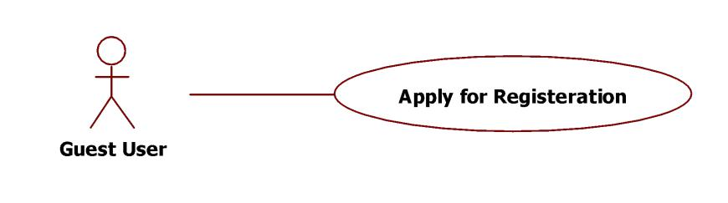

**Fig 3.1 Guest User**

The Guest User when first visit the website have to apply for registration in order to apply for any vacant drive.

**USER LOGIN FOR SCHEMES**

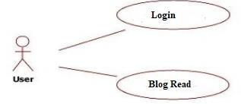

**Fig 3.2 User login for schemes**

The User after registration can login to the site and apply for drive for getting information like recruitment process.

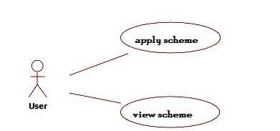**USER APPLY AND VIEW SCHEMES**

**Fig 3.3 User apply and view schemes**

The User after registration can login to the site and can apply and view available drive.

**ADMIN LOGIN AND WEBSITE REGISTER**

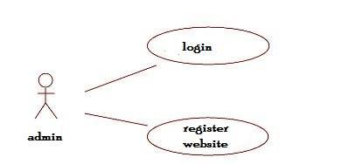

**Fig 3.5 Admin login and website register**

Admin only register the website and then generate the tokens.

**3.3 NON-FUNCTIONAL REQUIREMENTS**

**3.3.1 PERFORMANCE**

Performance is measured in terms of the output provided by the application. Requirement specification plays an important part in the analysis of a system. Only when the requirement specifications are properly given, it is possible to design a system, which will fit into required environment.

**3.3.2 RELIABILITY**

The requirement specification for any system can be broadly stated as The system should be able to interface with the existing system , The system should be accurate , The system should be better than the existing system , The existing system is completely dependent on the user to perform all the duties.

**3.3.3 PORTABILITY**

This site is portable to Google Chrome Browser i.e. site is best viewed with Google Chrome. But it can also work with other browsers like Internet Explorer, Mozilla Firefox etc.

**3.3.4 SECURITY**

User credentials should be encrypted so as to ensure confidentiality, integrity and availability and the project ideas should be protected so as to avoid being stolen by other parties.

**4. DESIGN AND IMLEMENTATION**

**4.1 DIAGRAM**

**USE-CASE DIAGRAM**

In particular, they recognize the need to solve recurring architectural problems, such as physical distribution, concurrency, replication, security, load balancing and fault tolerance, Additionally the development for the World Wide Web, while making some things simpler, has exacerbated these architectural problems.

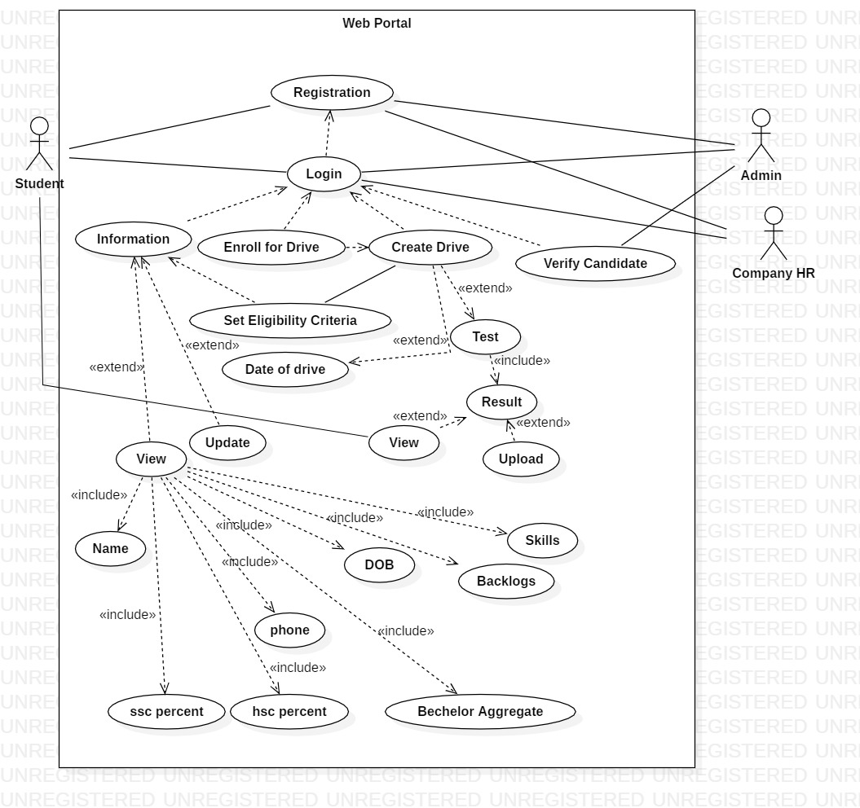

**Fig 4.1: Use Case Diagram**

**CLASS DIAGRAM**

The class diagram is the main building block of object oriented modeling. It is used both for general conceptual modeling of the systematic of the application, and for detailed modeling translating the models into programming code.

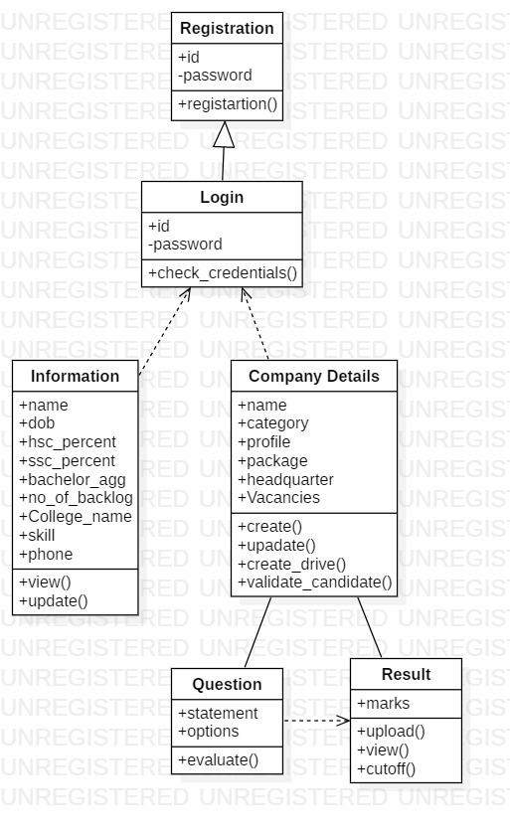

**Fig 4.2: Class Diagram**

**SEQUENCE DIAGRAM**

Sequence diagrams show a detailed flow for a specific use case or even just part of a specific use case. User Interaction sequence diagram having login steps.They are almost self-explanatory. They show the calls between the different objects in their sequence and can show, at a detailed level, different calls to different objects**.**

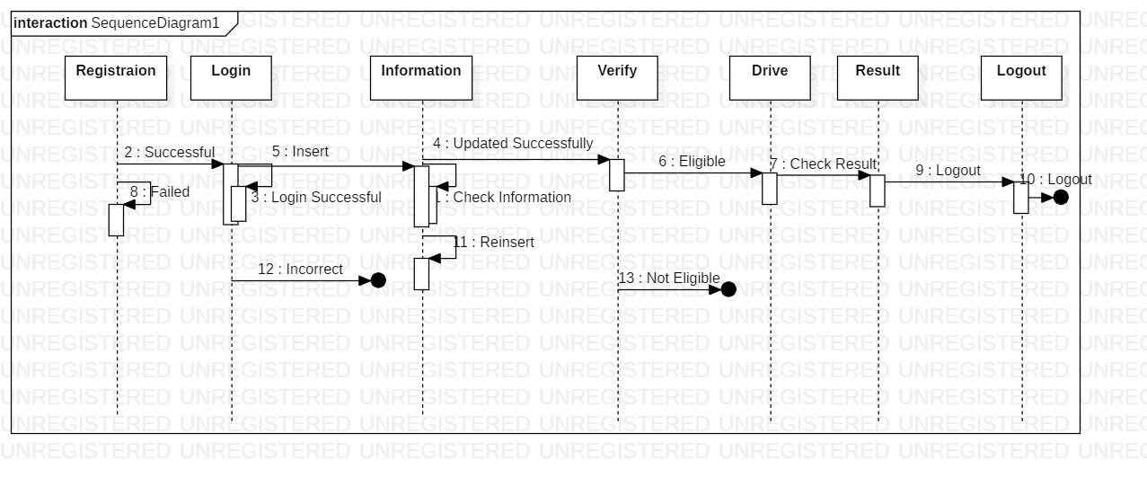

**Fig 4.3: Sequence Diagram**

**4.2 DATABASE**

**Examination Panel**

* First candidate Login
* After login exam instruction are shown to candidate
* And start button at the bottom to start the exam
* After clicking on start timer is start
* No of question is showing in right side and showing the question is answered, marked or not answer
* Exam is submit by user or auto submit after time up
* After submit exam result is send to admin and shortlist student get result by mail

**Candidate view**

* Candidate login to panel
* In the panel candidate can edit profile, view test, apply for companies
* In edit profile candidate can add more details about candidates or edit details which he added
* In view test section candidate can select company and give test
* After test complete it get result and get correct answer for every wrong answer.

**Admin Table**

admin_id (varchar, primary key)

name (text)

password (text)

**Candidate Table**

candidate_id (varchar, primary key)

password (text)

name (text)

date_of_birth (date)

hsc percent (float)

ssc percent (float)

bachelor aggregate (float)

no_of_current_backlogs (int)

college_name (text)

skills (text)

phone number (long)

**Company Table**

Company_id (varchar, primary key)

Name (text)

Category (text)

Headquarters (text)

Job_profile (text)

Package (text)

Date_of _exam (date)

No_of_vacancies (int)

**Questions_bank Tables**

Question_id (varchar, primary key)

Question_category (text)

Question_statement (text)

Question_options (text)